# Project Phase 2

# Real-Time Traffic Monitoring System

# 1. RoadNetwork Class

The RoadNetwork class models the road network as a graph, with junctions as nodes and the roads linking them as edges. Each edge is allocated a traffic weight, which may denote variables such as road distance, congestion levels, or other metrics affecting traffic flow. This solution employs an adjacency list representation, an efficient method for storing and traversing the network. In the script, three junctions, designated as "A," "B," and "C," are included into the network. Roads are constructed between these crossroads, with weights of 5 and 3 designated to represent their corresponding traffic circumstances. This framework renders the system very versatile, allowing for the seamless addition, removal, or modification of crossings and roadways. Furthermore, the adjacency list structure optimizes memory use, particularly for sparse networks, while facilitating rapid access to related nodes and their traffic weights. The scalability and simplicity provide the RoadNetwork class a crucial element for modeling and evaluating traffic networks.

# 2. TrafficEventQueue Class

The TrafficEventQueue class manages real-time traffic events, including accidents, traffic congestion, and other emergencies, according to their priority. This is executed via a priority queue, whereby events of greater priority are addressed prior to those of lesser importance. This approach use numerical values to denote priority, where lower numbers signify more significance. The script illustrates this by including two events: one detailing an accident at junction "A" with priority 1, and another indicating excessive traffic on the route between "A" and "B" with priority 2. During event processing, the accident is addressed first owing to its elevated priority. This function is essential for a real-time traffic monitoring system, as it guarantees the rapid resolution of major problems, hence enhancing traffic flow and minimizing delays. Upon processing both events, the queue is verified to be empty, indicating that the system effectively handles and resolves reported occurrences. A heap-based solution guarantees that event addition and retrieval occur in logarithmic time, making this method both time-efficient and scalable for extensive systems.

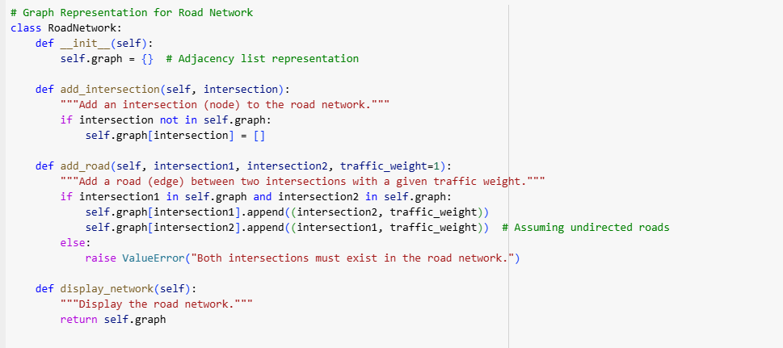

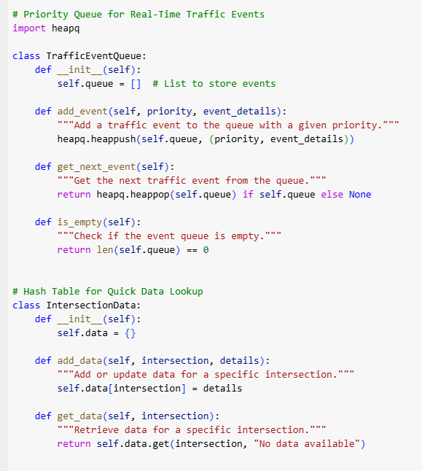

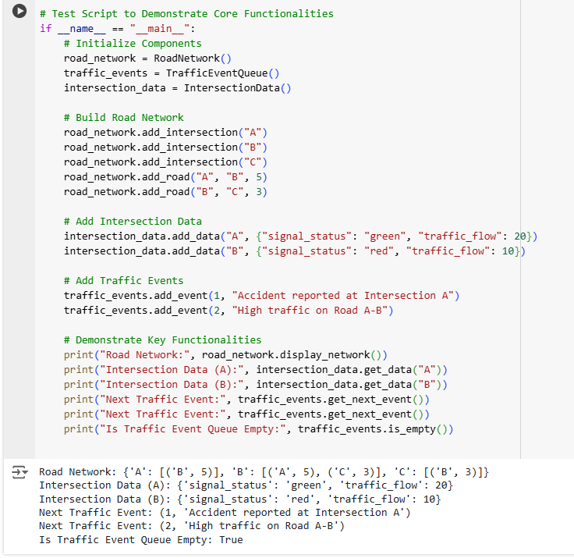

# 3. IntersectionData Class

The IntersectionData class functions as a repository for data pertaining to certain junctions. This may include information such as signal status (e.g., red or green), traffic flow rates, or other characteristics pertinent to traffic condition monitoring. The script contains data for intersections "A" and "B." Intersection "A" displays a green light with a traffic flow of 20 cars, whilst intersection "B" exhibits a red signal with a traffic flow of 10 vehicles. This data is then accessed to illustrate the class's capacity to efficiently store and provide intersection-specific information. The class employs a hash table, facilitating constant-time access to stored data. This guarantees that the system can swiftly provide pertinent information to users or other system components, such as traffic planners or automated systems executing routing choices. This class is essential to the traffic monitoring system because to its capability to store and retrieve comprehensive data for each junction, allowing for adaptation to changing circumstances and the provision of actionable insights.

# 4. Output Explanation

The script's output verifies the accuracy and efficacy of the implemented components. The road network is represented as a dictionary, illustrating the links between junctions and their corresponding weights. The graph demonstrates that intersection "A" is linked to "B" with a weight of 5, while "B" is linked to "C" with a weight of 3. This confirms the precision of the graphical depiction. Likewise, intersection-specific data is accurately gathered, with the script presenting information such as light status and traffic flow for junctions "A" and "B." Traffic incidents are addressed in the appropriate order of precedence, guaranteeing that essential occurrences, such as the collision at junction "A," are managed prior to less pressing matters, such as elevated traffic between "A" and "B." The script ultimately verifies that the event queue is devoid of entries after the processing of all events, underscoring the effective management and resolution of reported concerns. The result demonstrates unequivocal proof that the system operates as designed, establishing a robust basis for forward development.

# 5. Scalability and Extensibility

A notable characteristic of this solution is its modular architecture, allowing each component—the road network, event queue, and intersection data—to function autonomously while integrating cohesively. This modularity makes the system very scalable and extendable. New junctions and roads may be included into the RoadNetwork without affecting the functioning of existing components. The TrafficEventQueue may include supplementary event categories, such road closures or weather-related interruptions, with little modifications to its implementation. The IntersectionData class may be augmented to provide more intricate data, such as pedestrian traffic or adjacent areas of interest. Additionally, the system may interface with additional data sources, such as APIs that provide real-time traffic updates, to dynamically modify road weights or event priority. This adaptability guarantees that the system may progress to accommodate the requirements of bigger, more intricate traffic networks while preserving its fundamental features.

# 6. Advantages of the Implementation

This implementation provides several significant benefits. The modularity guarantees that each component may be designed, tested, and maintained autonomously, therefore reducing complexity and enhancing dependability. Secondly, using efficient data structures, such as adjacency lists for the road network and a heap-based priority queue for events, guarantees optimal system performance as the traffic network expands. Third, the priority-based event handling ensures that essential matters are dealt swiftly, enhancing traffic management and minimizing delays. The hash table implementation for junction data facilitates rapid access to comprehensive information, allowing the system to promptly react to inquiries or changes in traffic circumstances. The fundamental error management included in the system, such as verifying the existence of junctions prior to road addition, preserves data integrity and mitigates execution difficulties. Collectively, these attributes make the solution resilient, efficient, and well suited for real-time traffic surveillance.

# 7. Potential Future Enhancements

The existing implementation functions well as a robust proof-of-concept, however there are several avenues for augmenting its capabilities. The road network may be rendered dynamic, with road weights adjusted in real-time to mirror fluctuating traffic situations. For instance, if an accident transpires on a roadway, its weight may be augmented to deter navigation along that route. Secondly, route optimization methods, such as Dijkstra's or A*, may be included to determine the shortest or most expedient paths between crossings. Third, a graphical interface might be created to illustrate the road network and provide real-time traffic conditions, enhancing the system's user-friendliness. Fourth, the system might integrate with real-time traffic data sources, such as GPS or IoT devices, to provide current information and enhance decision-making. Ultimately, sophisticated analytics and machine learning methodologies may be used to forecast traffic trends and suggest preemptive strategies to mitigate congestion. These additions would significantly augment the system's capabilities, converting it into a holistic traffic management solution.

# 8. Conclusion

This proof-of-concept application effectively illustrates the fundamental features of a Real-Time Traffic Monitoring System. The system offers a robust basis for future growth by using graph-based modeling for the road network, a priority queue for handling traffic events, and a hash table for storing intersection-specific data. The outcome verifies the accuracy of the implementation, including precise road network modeling, effective event management, and dependable data retrieval. The system's flexibility, scalability, and efficiency make it very effective for tackling real-world traffic issues. Through future improvements like dynamic updates, route optimization, and real-time data integration, the system may transform into a robust instrument for traffic monitoring and management.